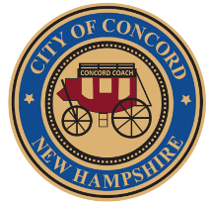

CITY OF CONCORD
New Hampshire’s Main Street™
Community Development Department

REPORT TO THE MAYOR AND CITY COUNCIL

FROM: Matthew R. Walsh, Deputy City Manager for Development

DATE: January 13, 2025

SUBJECT: License Agreement – Marathon Sports Awing located at 142 North Main Street

Recommendation

Accept this report recommending approval of a license agreement for an awning sign located within the public right of way at 142 North Main Street.

Background

Runner’s Alley located at 142 North Main Street is becoming Marathon Sports. As such, Marathon Sports desires to replace the current Runner’s Alley awning. The awning is located within the City’s highway right-of-way. As such, a license agreement from the City is required for installation of the new awning.

Discussion

The applicant’s proposed awning will project horizontally approximately 4’ over the sidewalk. The applicant has confirmed that the bottom of their proposed awning would provide 9’ of vertical clearance from the sidewalk which is acceptable for downtown snow removal. This minimum clearance is a requirement of the license.

Please see attached awning and signage application for more detail. Said application was approved by the City’s Planning Board on December 18, 2024.

