CITY OF CONCORD
New Hampshire’s Main Street™
Concord Human Services

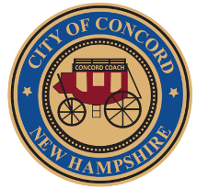

Karen Emis-Williams
Director of Concord Human Services

To: Honorable Mayor and City Council
From: Karen Emis-Williams
Re: Authorization to expend the donation of $765.00
Date: 12/20/2024

Recommendation

It is recommended that City Council approve the acceptance and expenditure of the above cited monetary donation from the Beaver Meadow Village Association.

Background

Funds are requested to be expended under the authority established pursuant to resolution number 8120 adopted December 10, 2007.

The purpose of this gift, donation or grant as stated above are a condition of the grantor or benefactor and is consistent with and presents no conflict or obstacle to the accomplishment of city council goals, the code of ordinances or the operating functions of the department.

A copy of this communication has been sent to the grantor or benefactor for their information and with the thanks of the City Council and the citizens of the City of Concord.

Discussion

We received a donation from the Beaver Meadow Village Association designated for our Christmas program. The donor requests that these funds be used to purchase Christmas gifts for children including teenagers. We are very grateful for this generous donation.

Cc: City Manager
City Clerk
Beaver Meadow Village Association

