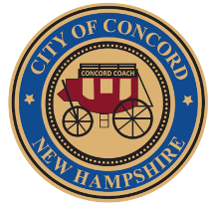

CITY OF CONCORD
New Hampshire’s Main Street™
Finance

Audrey D. Masters
Assistant Finance Director

REPORT TO MAYOR AND THE CITY COUNCIL

FROM: Audrey Masters, Assistant Finance Director

DATE: December 17, 2024

SUBJECT: FY2024 Year End Annual Comprehensive Financial Report, Single Audit Report, and Governance Letter

Recommendation

Accept the attached Annual Comprehensive Financial Report (ACFR), Single Audit Report (SAR), and Governance Letter for the Fiscal Year Ended June 30, 2024.

Background

Each year, the City contracts for and receives an independent audit of its financial records. The resulting Annual Comprehensive Financial Report (ACFR) is made available to the City Council and the public. Scott McIntire from Marcum presented the attached ACFR, SAR, and Governance Letter to the Fiscal Policy Advisory Committee (FPAC) at its regularly scheduled December 16, 2024 meeting. The independent auditors report begins on page 14 of the ACFR. The Single Audit Report (SAR) is a result of the Single Audit, which is a comprehensive financial statement and federal awards audit designed to comply with both Government Auditing Standards and the Uniform Guidance.

Discussion

The audit report and its data are accurate in all material respects and are reported in a manner designed to fairly present the City’s financial position and the results of the operations of the various funds.

